Data Mining Architecture
The significant components of data mining systems are a data source, data mining engine, data warehouse server, the pattern evaluation module, graphical user interface, and knowledge base.
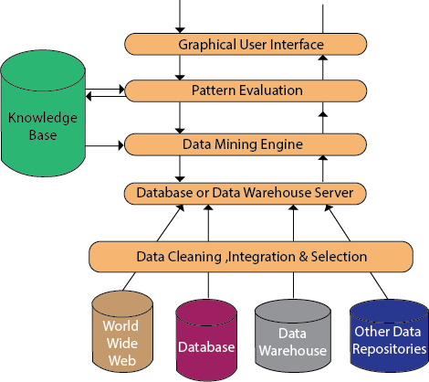

Data Source:
The actual source of data is the Database, data warehouse, World Wide Web (WWW), text files, and other documents. You need a huge amount of historical data for data mining to be successful. Organizations typically store data in databases or data warehouses. Data warehouses may comprise one or more databases, text files spreadsheets, or other repositories of data. Sometimes, even plain text files or spreadsheets may contain information. Another primary source of data is the World Wide Web or the internet.

Different processes:
Before passing the data to the database or data warehouse server, the data must be cleaned, integrated, and selected. As the information comes from various sources and in different formats, it can't be used directly for the data mining procedure because the data may not be complete and accurate. So, the first data requires to be cleaned and unified. More information than needed will be collected from various data sources, and only the data of interest will have to be selected and passed to the server. These procedures are not as easy as we think. Several methods may be performed on the data as part of selection, integration, and cleaning.

Database or Data Warehouse Server:
The database or data warehouse server consists of the original data that is ready to be processed. Hence, the server is cause for retrieving the relevant data that is based on data mining as per user request.

Data Mining Engine:
The data mining engine is a major component of any data mining system. It contains several modules for operating data mining tasks, including association, characterization, classification, clustering, prediction, time-series analysis, etc.
In other words, we can say data mining is the root of our data mining architecture. It comprises instruments and software used to obtain insights and knowledge from data collected from various data sources and stored within the data warehouse.

Pattern Evaluation Module:
The Pattern evaluation module is primarily responsible for the measure of investigation of the pattern by using a threshold value. It collaborates with the data mining engine to focus the search on exciting patterns.
This segment commonly employs stake measures that cooperate with the data mining modules to focus the search towards fascinating patterns. It might utilize a stake threshold to filter out discovered patterns. On the other hand, the pattern evaluation module might be coordinated with the mining module, depending on the implementation of the data mining techniques used. For efficient data mining, it is abnormally suggested to push the evaluation of pattern stake as much as possible into the mining procedure to confine the search to only fascinating patterns.

Graphical User Interface:
The graphical user interface (GUI) module communicates between the data mining system and the user. This module helps the user to easily and efficiently use the system without knowing the complexity of the process. This module cooperates with the data mining system when the user specifies a query or a task and displays the results.

Knowledge Base:
The knowledge base is helpful in the entire process of data mining. It might be helpful to guide the search or evaluate the stake of the result patterns. The knowledge base may even contain user views and data from user experiences that might be helpful in the data mining process. The data mining engine may receive inputs from the knowledge base to make the result more accurate and reliable. The pattern assessment module regularly interacts with the knowledge base to get inputs, and also update it.

Stages of Data Mining
